.

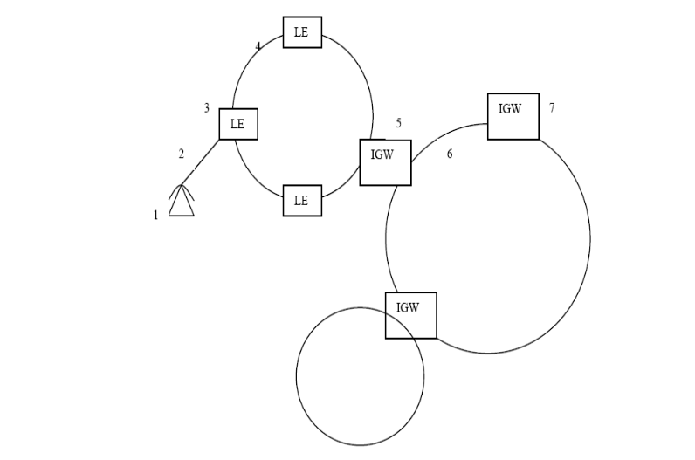
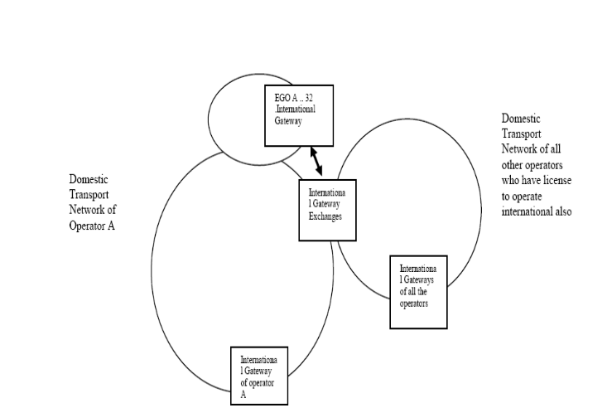
Item No: 1: To understand the general communication network and the network multi operators.

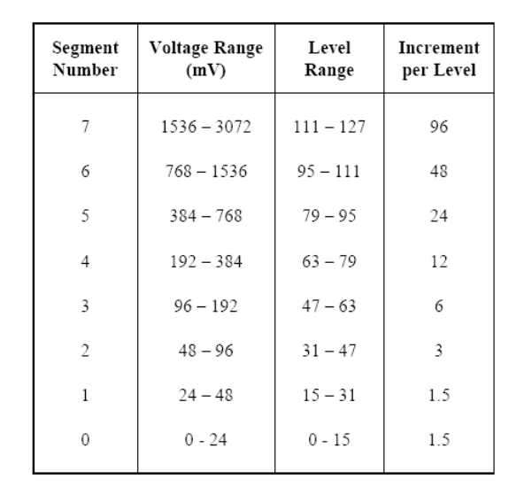
Item No: 2 : TO understand the non-linear quantizing.
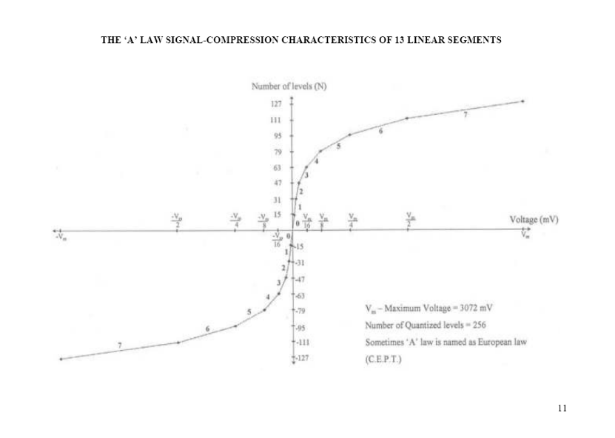

Item NO:3 :To understand the Time division multiplexing Item No: 4 : TO understand the synchronization
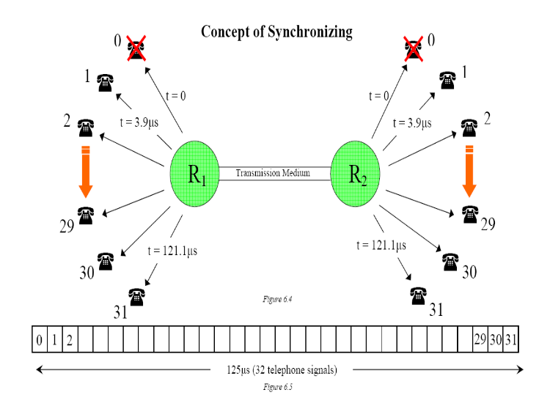
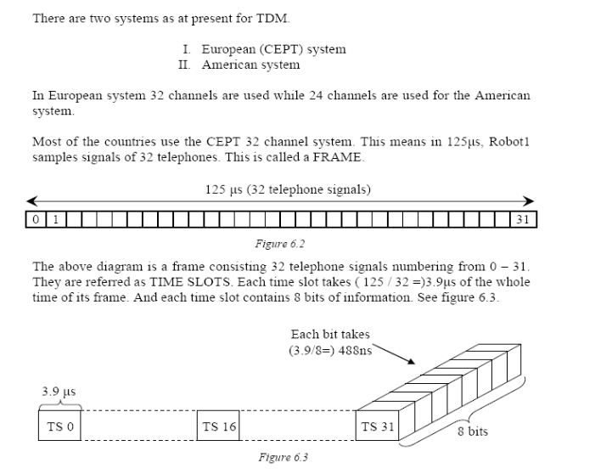
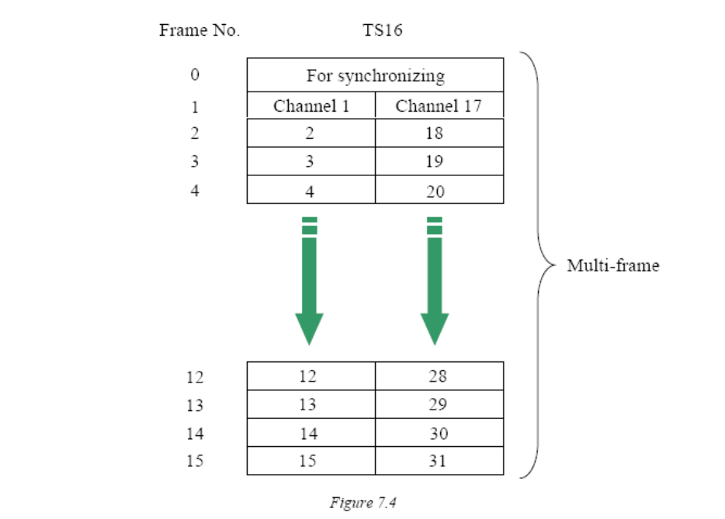
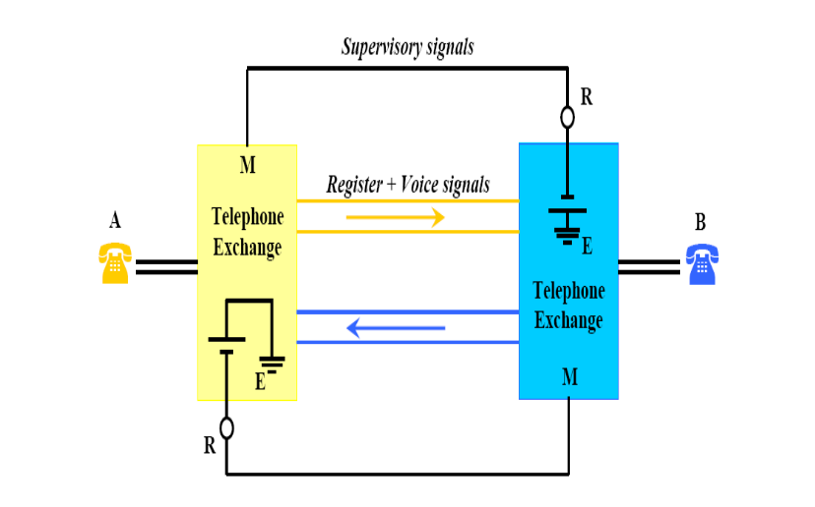
Item NO: 5: TO understand the channel associated signaling Item No: 6: To understand how the supervisor signals moves

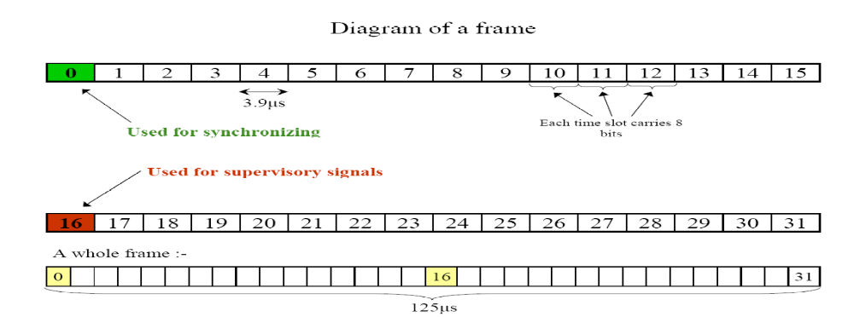
Item No 7: To understand the concept of a frame
Item No: 8.2: To understand the concept of a repeater

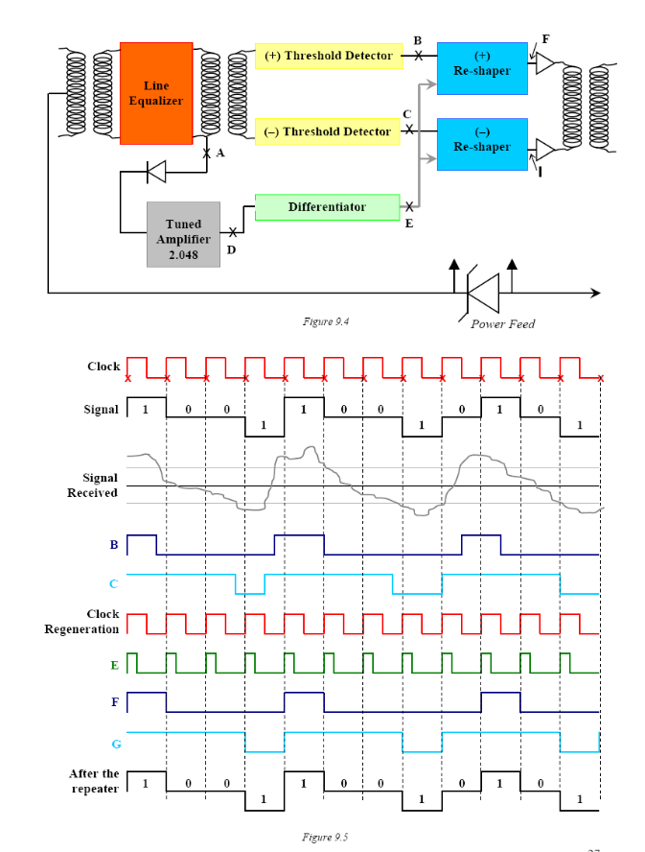
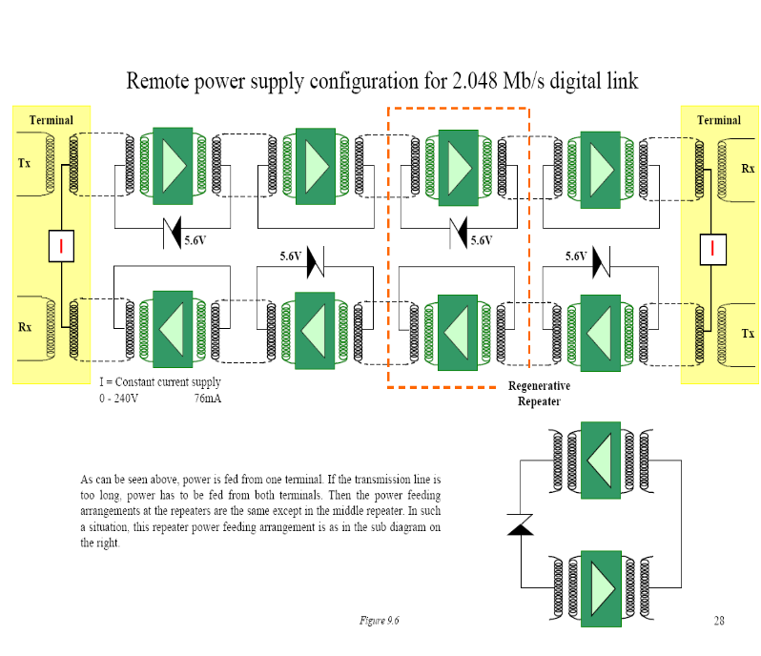
Item no: 8.1 –Power feeding

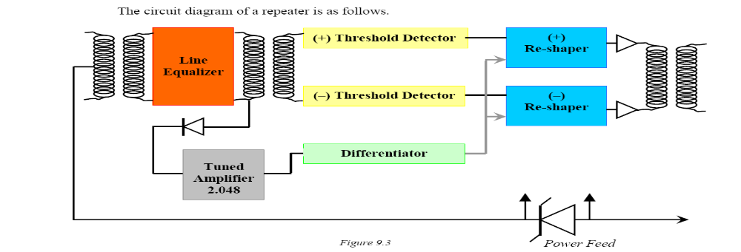
Item No 8.3: Reshaping
Item no: 10.1: Practical systems of higher order PDH systems byte interleaving

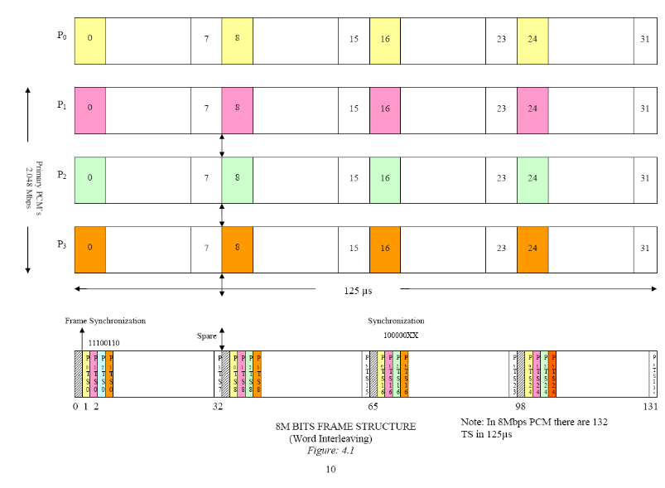
Item No: 9 : TO understand the working of HDB3
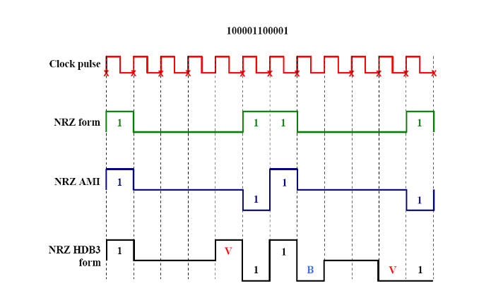

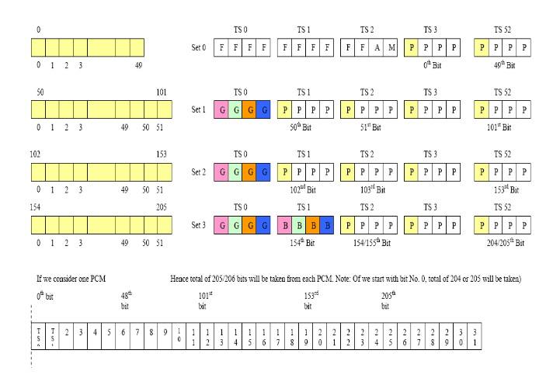
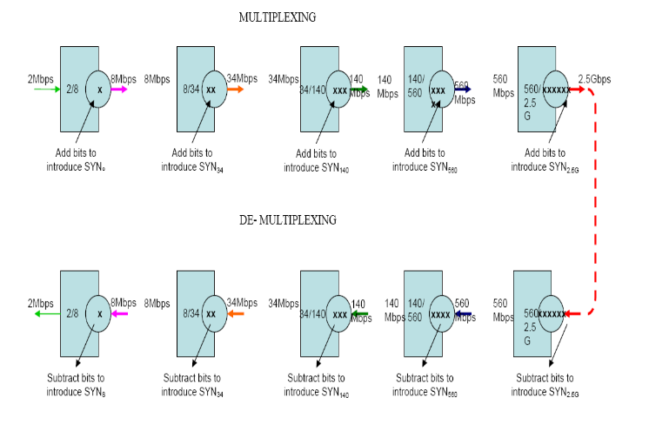
Item no: 10.2 –Practical PDH systems bit synchronization Item No: 11: PDH multiplexing concept

Item no: 12.1 – Concept of SDH


