.
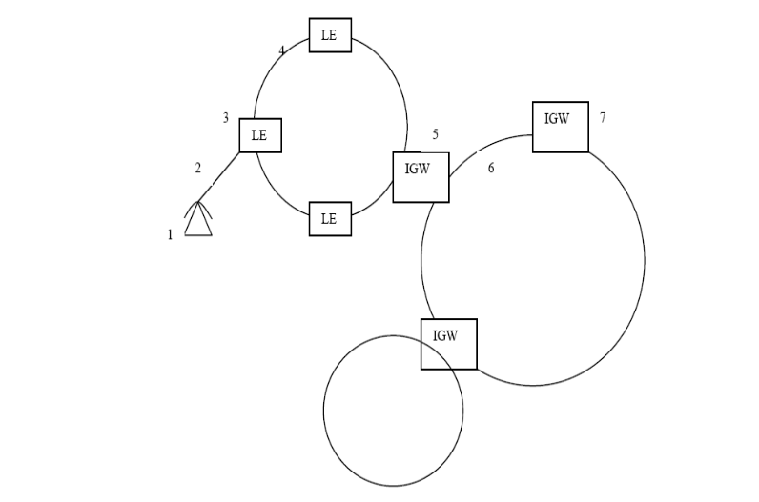
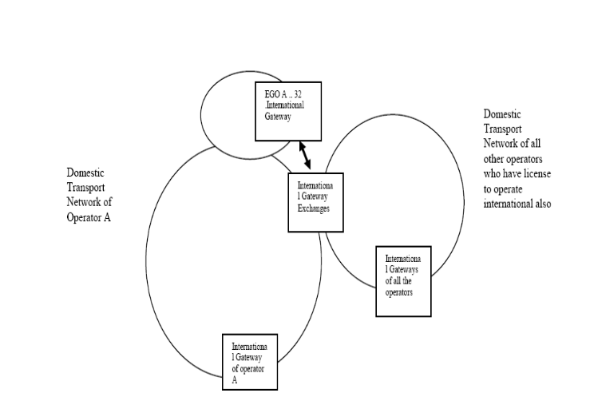
Item No: 1: To understand the general communication network and the network multi operators.
2 How sampling theory works
3.Non-linear quantizing

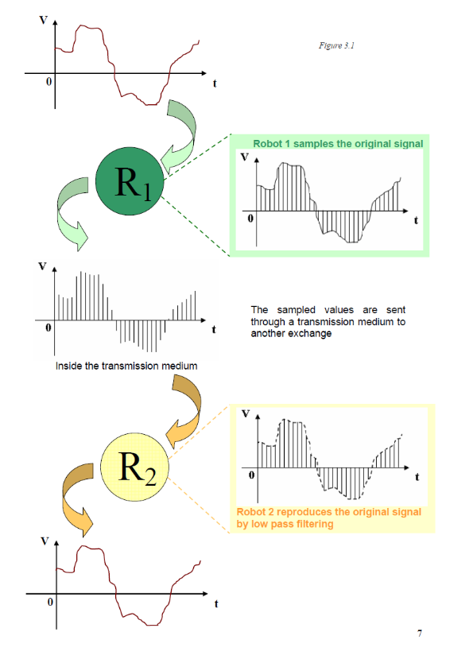
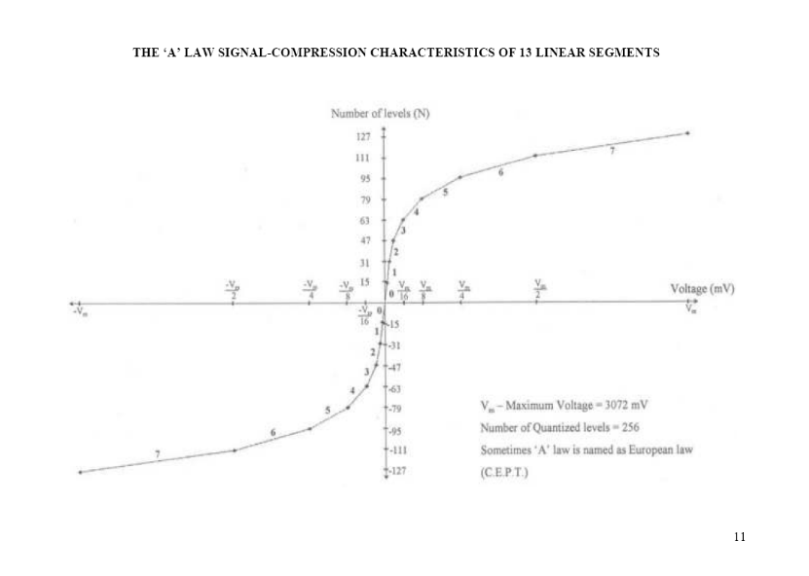

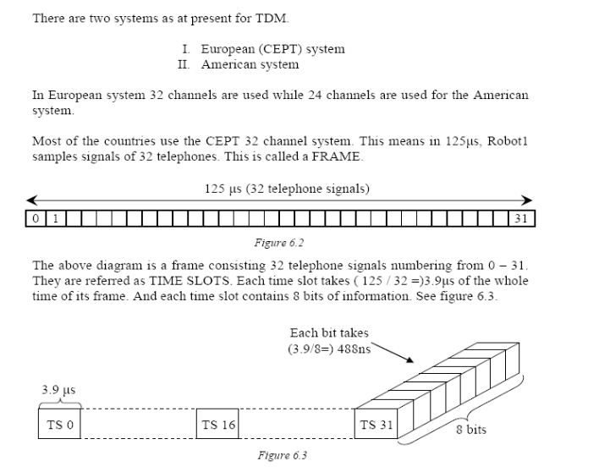
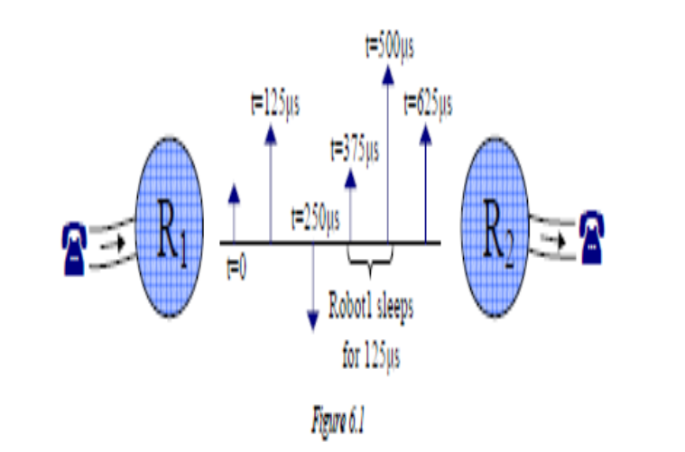
4 Concept of time division multiplexing

Item No: 5 : TO understand the synchronization Item No: 6: To understand how the supervisor signals moves
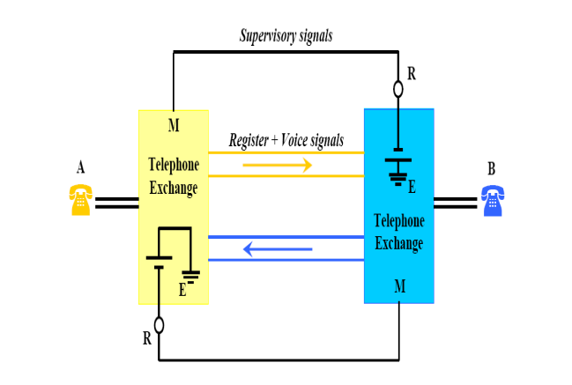
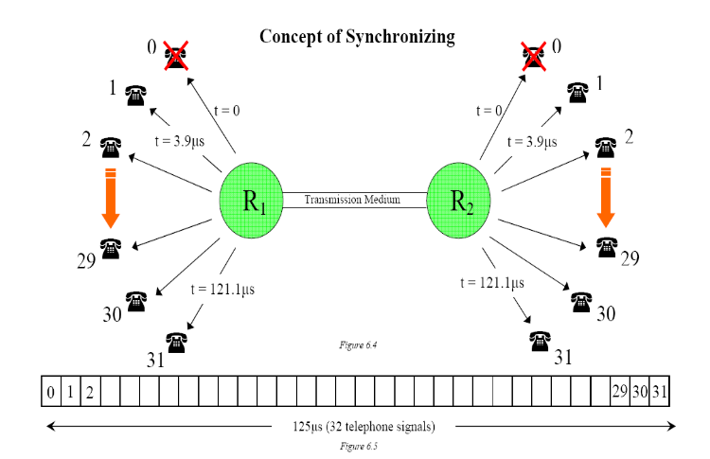

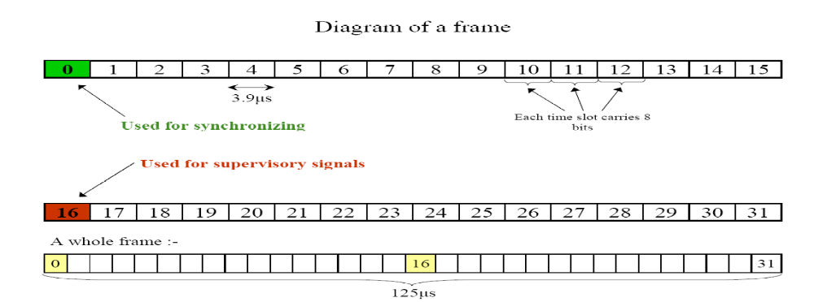
Item No 7: To understand the concept of a frame, and 1 TO understand the channel associated signaling
Item No: 9: To understand the concept of a repeater

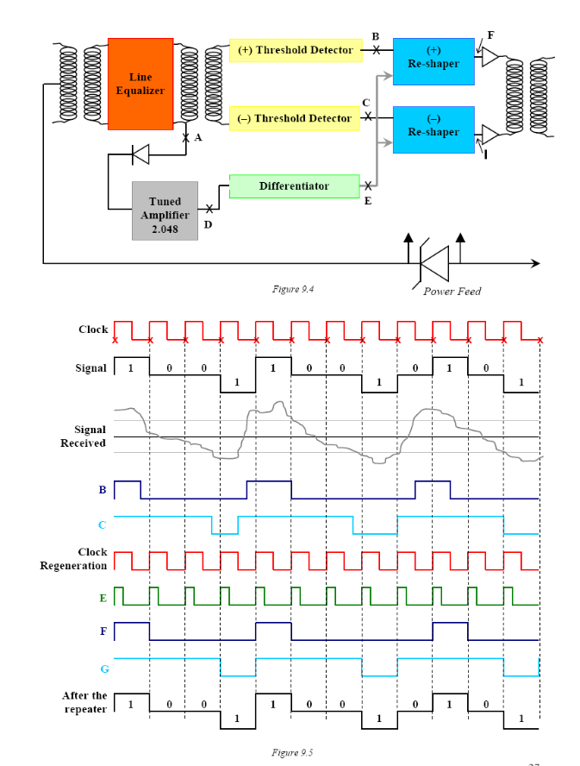
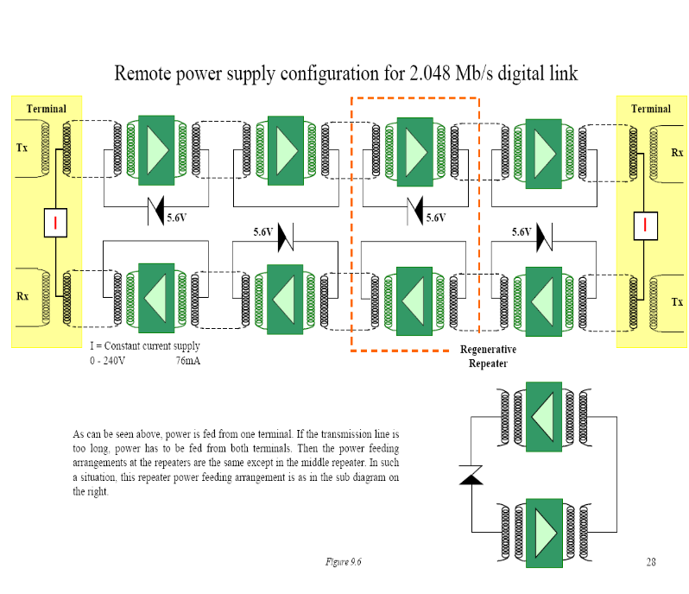
Item no: 8–Power feeding

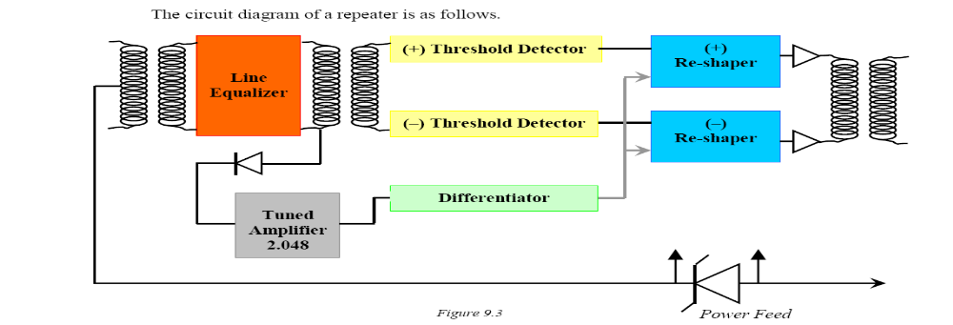
Item No 10: Reshaping
Item no: 12: Practical systems of higher order PDH systems byte interleaving

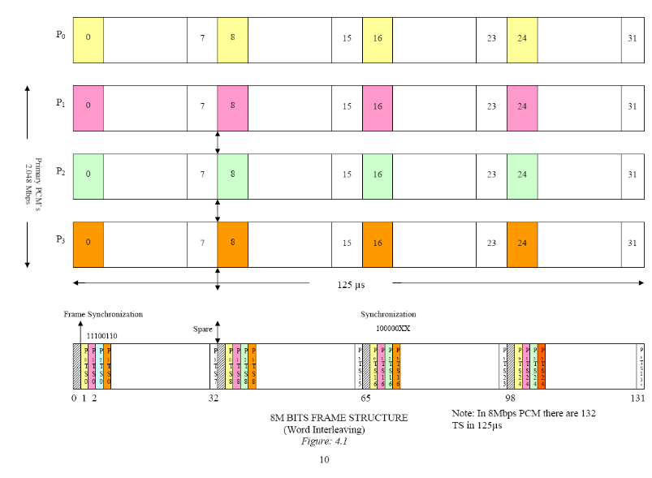
Item No: 11 : TO understand the working of HDB3
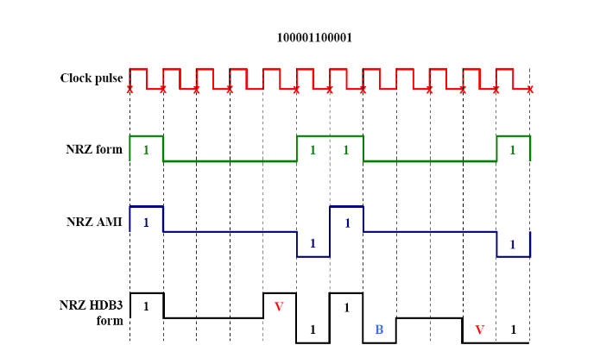

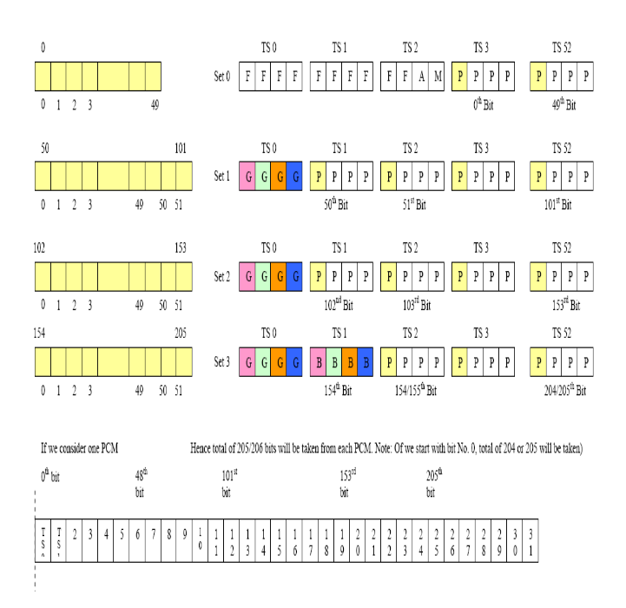
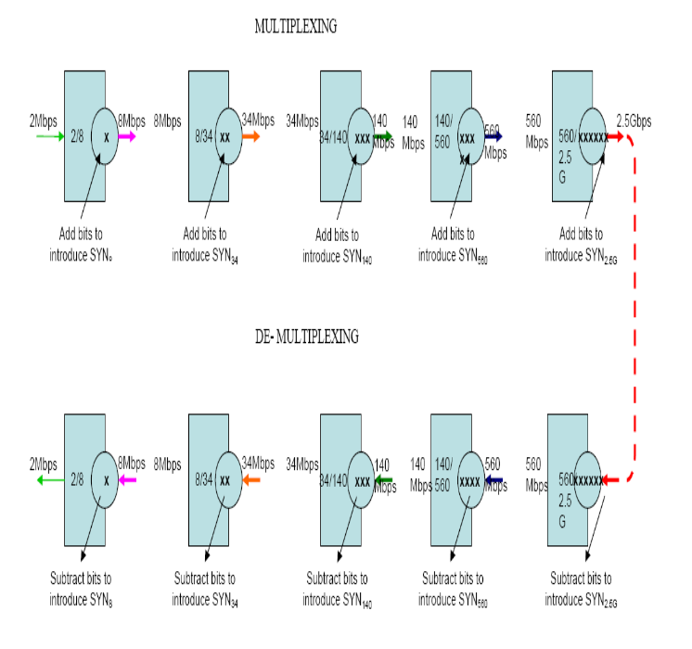
Item no: 13 –Practical PDH systems bit synchronization Item No: 14: PDH multiplexing concept

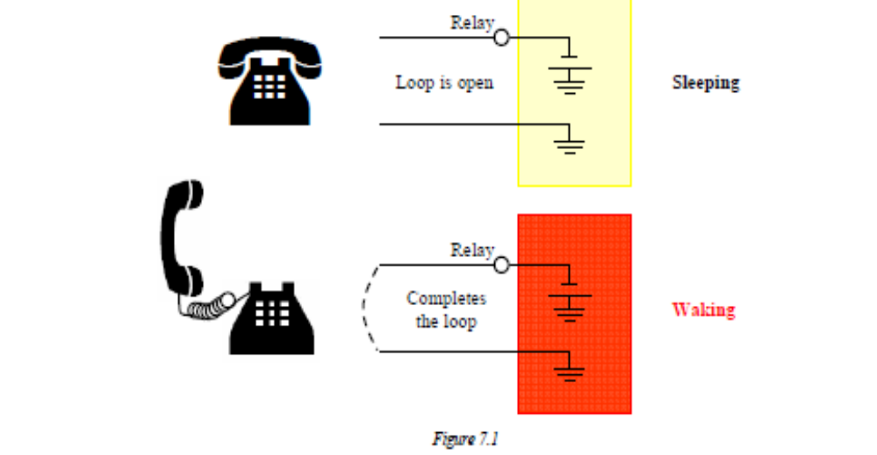
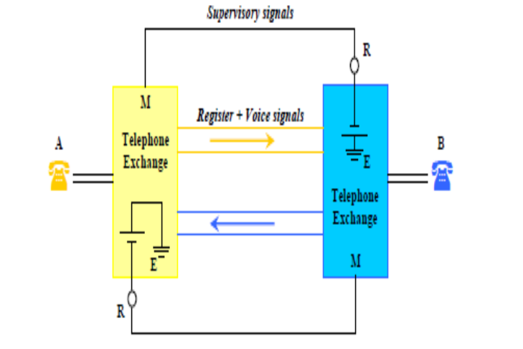
Item no: 15 :Signalling

Item no: 16 – Concept of SDH


